## [American University of Beirut logo](http://www.aub.edu.lb/)Faculty of Engineering & Architecture

### Department of Mechanical Engineering

#### Mech 341 – Materials Lab

#### Lab Report # 4

Section # 2 (3:30 to 4:00)

Due Wednesday, March 25th, 2009

Dr. Charbel Seif

Group Members:

**Introduction**

Materials is an important branch of engineering that deals with the study of diverse groups of materials which are at our fingertips. In fact, studying these materials is not that simple; on the contrary, each subject of study has a certain detailed profile taking into consideration the numerous factors one has to consider through the elaboration of ideas and applications of the test. There is a great number of tests that examine materials which are in turn manifold and of various groups. The complex interaction of a number of properties form up a certain curriculum vitae particular for each subject. Other than tensile tests (that we experimented in labs 1 and 2), and brinell hardness test, there is another kind of material experimentation called Impact Testing.

Impact tests are designed to measure the resistance to failure of a material to a suddenly applied force. The test measures the impact energy, or the energy absorbed prior to fracture. The most common methods of measuring impact energy are the:

•         Charpy Test

•         Izod Test

The behavior of materials is not always consistent and spontaneous. On the contrary, materials’ behaviour varies with respect to different conditions, some of which are:

* Deformation at a low temperature
* High strain rate
* Tri axial stress state

Impact testing serves us whenever we want to choose some material for a special application. As we noted earlier, there are two kinds of imapct testing. The major difference between the two is that the Charpy test specimen is gripped from each end while the Izod test specimen is gripped from only one end.

In our experiment we are going to use the Charpy V-notch test since it is inexpensive and easy to use, and as far as I know, it is the available one in AUB labs. The impact energies that we get are not used numerically to find related values, instead they are used relatively to other impact energies found. Therefore, they are used for comparisons and other qualitative purposes. In the light of this, we are going to use our lab results to compare the behaviour of steel with different conditions regarding carbon content, temperature and other factors. Also, we are going to compare these results with some of those of the previous labs.

To understand the significance of the Charpy impact testing, one has to know the physical meaning of impact energy.

Impact energy is a measure of the work done to fracture a test specimen.

When the striker impacts the specimen, the specimen will absorb energy until it yields. At this point, the specimen will begin to undergo plastic deformation at the notch. The test specimen continues to absorb energy and work hardens at the plastic zone at the notch. When the specimen can absorb no more energy, fracture occurs.

At the point of impact, the striker has a known amount of kinetic energy. The impact energy is calculated based on the height to which the striker would have risen, if no test specimen was in place, and this compared to the height to which the striker actually rises.

Tough materials absorb a lot of energy, whilst brittle materials tend to absorb very little energy prior to fracture

Charpy Impact testing is a destructive experiment as it pushes the material up to the stake of plastic deformation and even farther to fracture.

Something to add is that the Charpy Impact energy is affected by some factors, four of which are:

•         Yield strength and ductility

•         Notches

•         Temperature and strain rate

•         Fracture mechanism

**Charpy Testing Machine:**

One can view the simulation of the Charpy test for both ductile and brittle materials at: ***http://www.binaryblue.com.au/05\_charpy\_test.html***

The Charpy V-notch test consists of the machine used and the specimen to be studied. The specimen must have a V-notch, hence the test’s name. The V-notch makes it easier for the specimen to be fractured.

The notch serves as a stress concentration zone and some materials are more sensitive towards notches than others. The notch depth and tip radius are therefore very important.

The specimen should be uniform in its material and not include any fractures or differences in composition of material since test results will be altered. It should also be of standard dimensions. Several dimensions can be used.

**Dimensions of notch:**

45° angle, 2 mm deep and 0.25 mm root radius

**Dimensions of bar (excluding notch):**

(10 mmx10 mm) square cross section x 55 mm length

After the specimen is chosen and fixed to standard dimensions it’s ready for testing. We place the specimen at the bottom of the machine and grip it from both ends (since Charpy test is being used and not the Izod test). A hammer, mass pendulum, will drop freely from a certain height from which it was fixed, impact the specimen breaking it, and rise back to another height at opposite ends. The machine would have measured the difference in height and calculated the corresponding impact energy. This energy would be the energy absorbed by the specimen.



*It is calculated as follows:*

***Cv : the energy of hammer (measured in lbf).***

***m: mass of hammer***

***g: gravitational acceleration (9.81 m/s2 or its equivalent in British units)***

***h0: initial vertical height of hammer***

***h1: final vertical height of hammer***

Since h1 is less than h0, then C v will be negative so the hammer loses energy giving it to the specimen. Therefore, we denote C v (positive value) as the energy that the specimen absorbed. C v is also the measure of toughness of a material under impact loading.

Hence, Charpy Impact test gives us a certain review for a number of properties of a material along with the effect of some factors on this material, especially when we consider different samples with different carbon content, heat treatment, and temperature

**Note:** For more accurate results we need to measure the friction in the machine. To do so, we have to test our machine with no specimen placed between the grips. We get a certain Cv-friction and subtract that amount from the Cv that we read from the machine when each specimen was tested. In our case, we got energy of 1 lbf-ft lost due to friction (lost as heat).

**Problem approach:**

Fracture toughness is an indication of the amount of stress required to propagate a preexisting flaw. It is a very important material property since the occurrence of flaws is not completely avoidable in the processing, fabrication, or service of a material/component.

Flaws may appear as cracks, voids, metallurgical inclusions, weld defects, design discontinuities, or some combination thereof. Since engineers can never be totally sure that a material is flaw free, it is common practice to assume that a flaw of some chosen size will be present in some number of components and use the **linear elastic fracture mechanics (LEFM)** approach to design critical components. This approach uses the flaw size and features, component geometry, loading conditions and the material property called fracture toughness to evaluate the ability of a component containing a flaw to resist fracture.

In this experiment we are aiming at measuring the impact that a material can withstand before its fracture takes place and studying the result of notching the specimen at that energy.

The specimens under study are:

- Low Carbon Steel

- High Carbon Steel

- Heat-treated Carbon steel

In the experiment, we were able to measure the impact energies and as a consequence measure the toughness of these two materials. The interesting thing is that, by the results obtained, we were able to note the carburizing effect of steel on each of the toughness and the fracture behavior of the material. Moreover, each of the specimens above was tested in various temperature conditions. Low Carbon Steel as well as high carbon steel was tested at approximately -70°C using the liquid nitrogen to see the effect of temperature on the mechanical properties of carbon steel. Moreover, both specimens were tested at 4°C using a bottle of cold water at 4°C. It’s clear to see, after using the Charpy V-notch test to find Cv, that the shear lip decreases with decreasing temperature. Of course, the shear lip is then directly correlated to the ductility of the material under study as shown later on. A clearer analysis will be presented after performing the calculations.

The percentage of Shear lip is obtained by the following formula:



where A and B are the width and length of our original specimen respectively excluding the node. The values of A & B are given in the excel sheet.

The ductility of a material increases as a result of increasing shear lip. So, it will be enough to compare the fracture areas to see whether the materials studies in the lab are more ductile or less.

**Steps of problem approach are:**

1. The test specimen is placed in its appropriate position on the impact tester.

2. The weight arm is elevated to its initial position and released to impact the specimen.

3. After the impact, the gauge is read. It corresponds to the energy that is left in the weight arm.

4. The difference of the initial energy and the final energy equals the energy absorbed by the specimen.

5. The Shear lip of the fractured specimens is measured.

In the light of all what preceded, we will come to terms with important definitions and conclusions regarding the response of the material to a lot of factors, externally and internally.

|  |  |  |  |
| --- | --- | --- | --- |
| **Material** | **Cv (lbf-ft)** | **x (mm)** | **y (mm)** |
| **High Carbon Steel** | **16** | **8** | **6** |
| **High Carbon Steel Room at 4 C** | **16** | **8.5** | **6.5** |
| **High Carbon Steel Room at -70 C** | **9.5** | **8.5** | **7.5** |
| **High Carbon Steel Treated** | **2.5** | **9** | **7.6** |
| **Low Carbon Steel at Room Temperature** | **116** | **4** | **3** |
| **Low Carbon Steel at 4 C** | **113** | **5** | **3** |
| **Low Carbon Steel at -70 C** | **9** | **8.5** | **7.5** |

**Analysis and calculations:**

1. **Reporting the values observed in the lab**

Figure 1 in the appendix shows the fractured area of our specimen and its dimensions where we can see that x is the width of the square formed from fracture and y is its height.

The measurements we got from our test and are inserted in the above table.

1. **Calculation of the percent shear lip:**

We calculate the percent shear lip as:



Where A and B are the width and length of our original specimen respectively excluding the node (check figure 1 in appendix)

A = 10mm and B = 8mm

* **High Carbon Steel :**

**% shear lip** = 100\*((10mm)(8mm)-(8mm)(6mm))/((10mm)(8mm))  **=**100\*(80mm2-48mm2)/(80mm2) = 40%

* **High Carbon Steel at 4 C :**

**% shear lip** = 100\*((10mm)(8mm)-(8.5mm)(6.5mm))/((10mm)(8mm))

= 100\*(80mm2-55.25mm2)/(80mm2) = 30.9375 %

* **High Carbon Steel Room at -70 C :**

**% shear lip** = 100\*((10mm)(8mm)-(8.5mm)(7.5mm))/((10mm)(8mm))

= 100\*(80mm2-63.75mm2)/(80mm2) = 20.3125%

* **High Carbon Steel Heat Treated :**

**% shear lip** = 100\*((10mm)(8mm)-(9mm)(7.6mm))/((10mm)(8mm))  **=**100\*(80mm2-68.4mm2)/(80mm2) = 14.5%

* **Low Carbon Steel at Room Temperature :**

**% shear lip** = 100\*((10mm)(8mm)-(4mm)(3mm))/((10mm)(8mm))  **=**100\*(80mm2-12mm2)/(80mm2) = 85%

* **Low Carbon Steel at 4 C :**

**% shear lip** = 100\*((10mm)(8mm)-(5mm)(3mm))/((10mm)(8mm))  **=**100\*(80mm2-15mm2)/(80mm2) = 81.25%

* **Low Carbon Steel at -70 C :**

**% shear lip** = 100\*((10mm)(8mm)-(8.5mm)(7.5mm))/((10mm)(8mm))  **=**100\*(80mm2-63.75mm2)/(80mm2) = 20.3125%

1. **Shear lip and Ductility Correlation:**

|  |  |  |  |
| --- | --- | --- | --- |
| **Material** | **Shear Lip (%)** | **Fracture Surface** | **ductility** |
| **High Carbon Steel** | 40 % | Granular flat smooth surface | Significantly less ductile than Low Carbon Steel at 4 C |
| **High Carbon Steel at 4 C** | 30.9375 % | Flatter than high C Steel with some convolutions | Less ductile than high carbon steel at room temperature |
| **High Carbon Steel at -70 C** | 20.3125 % | Less flat than the heat treated high C with very little convolution | Less ductile than high carbon steel at 4 C and approximately equal to Low carbon steel at -70 C |
| **High Carbon Steel Heat Treated** | 14.5 % | Flat smooth surface | Least ductile material |
| **Low Carbon Steel at Room Temperature** | 85 % | fibrous | Most Ductile |
| **Low Carbon Steel at 4 C** | 81.25 % | Mostly granular | Slightly less ductile than low carbon steel at room temperature |
| **Low Carbon Steel at -70 C** | 20.3125 % | Less flat than the heat treated high C with very little convolution | Approximately equal in ductility to high carbon steel at -70 C |

**Correlating shear lip and ductility:**

*From above table results, there is a clear relation between percentage shear lip and ductility. As percentage shear lip increases, ductility increases; that is a high shear lip percentage indicates high ductility and vice versa. From table, low carbon steel is the most ductile material and high carbon steel heat treated is the least ductile.*

* **Observations and Analysis of experiment:**

1. Low carbon steel at room temperature absorbed the highest amount of energy which is 116 lbf-ft; however, brittle materials such as high carbon steel, low carbon steel at -70 C, high carbon steel heat treated, and high carbon steel at -70 C absorbed much less than that, and the results were: 16, 9, 2.5, and 9.5 bf-ft respectively. This is a definite sign of the relation between ductility and toughness. At room temperature, the harder is the material, the less is its toughness.
2. Upon the cooling of the low carbon steel to -70 C, brittle behavior was shown by absorbing 9 lbf-ft. This proves the change in behavior upon cooling, from ductile to brittle. Moreover, at -70 C, both, the high carbon steel and low carbon steel, absorb 9 bf-ft which indicates the decreasing effect of temperature with the extreme decrease in temperature.
3. Fracture Toughness vs. Modulus of Toughness: In lab 1 and two we tested the modulus of toughness of low and high carbon steels at room temperatures.

|  |  |  |  |
| --- | --- | --- | --- |
| **Material** | **Modulus of Toughness** | **Fracture Toughness** | **Brinell Hardness** |
| Low Carbon Steel | 59.81 MJ/m3 | 116 lbf-ft | 168 |
| High Carbon Steel | 45.2 MJ/m3 | 16 lbf-ft | 204 |
| Percentage Difference of Values Between Steels | 32.323 % | 86.207 % | 21.429 % |

While the modulus of toughness is the measure of the work done on a unit volume of the material until fracture, the fracture toughness is the amount of energy absorbed to achieve fracture.

From previous experiments, it is obvious that low carbon steel has higher modulus of toughness as well as fracture toughness, where the difference is way greater and much more significant when it comes to fracture toughness which has a percentage difference up to 86.207%.

We may conclude with some observations that high carbon steels will allow less plastic deformation, than their low carbon counterparts, as they are brittle and thus will fracture before reaching significant changes.

1. Brinell Hardness vs. Fracture Toughness:

Previous-performed experiments showed the considerable difference between the hardness number of the low and high carbon steels. Their percentage difference was as high as 21.429%. However, fracture toughness and modulus of toughness are both higher for low carbon steel which shows an inversely proportional relation between hardness number on one hand, and fracture toughness and the modulus of toughness on the other hand.

1. Fracture Toughness: is a quantitative property of a cracked material to resist fracture and has the unit of MPa $\sqrt{m}$. With large values for fracture toughness, ductile fracture is most probable, and vice versa.
2. We observed that the surface of the ductile material is more fibrous, representing the nature of the metal while the brittle material has a granular surface.
3. It is of importance to differentiate between toughness and hardness. Hardness is the ability to resist plastic deformation and increases in brittle materials, however toughness is the total amount of energy absorbed by the material before failure and it is much higher for ductile materials.
4. It is important to understand the temperature conditions the material will be in, and stay away from the transition temperature which will change the material’s properties from ductile to brittle ones (as temperature decreases) especially for low carbon concentration.

* **Ranking the toughness energy of some representative materials of the three basic families of materials:**

Fracture toughness is a quantitative way of expressing a material's resistance to [brittle](http://en.wikipedia.org/wiki/Brittle) fracture when a crack is present. If a material has a large value of fracture toughness it will probably undergo [ductile](http://en.wikipedia.org/wiki/Ductile) fracture. Brittle fracture is very characteristic of materials with a low fracture toughness value. It can be well noticed that metals have the highest fracture toughness values among all other materials. This is in fact clear since metals are known to be tough materials ( i.e can absorb a large amount of energy before fracture). It is clear to notice that Ceramics comes after Metals in the value of their fracture toughness and then are polymers.

We can rank the toughness of major materials as follows (in decreasing order):

**Metals:** Metals consist of two groups: ferrous and nonferrous. Ferrous are metals that include mostly iron in them. The metal group is very large and it is the toughest of all three groups for several reasons. The main reason is that dislocations are easier to occur in metals since all the ions present are electrically neutral making slips more probable.

**Plastics:** Plastics have toughness between metals and ceramics because of their molecular properties. Some plastics are rigid and brittle while others are flexible, exhibiting considerable deformation before fracture.

**Ceramics:** The ceramics crystal structures are more complex than metals. The bonds between the molecules range form purely ionic to totally covalent. The degree of ionic character depends on the electro negativities of the atoms. There are two types of ceramics: crystalline and noncrystalline. Both types usually fracture before any plastic deformation occurs. They are brittle material with very little energy absorption.

For crystalline material, plastic deformation occurs due to motion of dislocations. Since the material is difficult to slip not much plastic deformation results. For slips to occur ions of like charge are brought close together and this is very hard to achieve. As for metals, all ions are electrically neutral so slips are more probable and achievable. For ceramics which are bonded covalently, it’s even harder for dislocations to occur and energy to be accepted in the plastic deformation. This is due to the strength of the covalent bonds, the limited number of slip systems, and the complexity of dislocation structure. As for noncrystalline ceramics, plastic dislocation does not occur in them since they don’t have a regular atomic structure.

## Table of values

Here are some typical values of fracture toughness for various materials:

|  |  |
| --- | --- |
| Material | KIc (MPa-m1 / 2) |
| **Metals** | |
| [Aluminum](http://en.wikipedia.org/wiki/Aluminum) alloy (7075) | 24 |
| [Steel](http://en.wikipedia.org/wiki/Steel) alloy (4340) | 50 |
| [Titanium](http://en.wikipedia.org/wiki/Titanium) alloy | 44-66 |
| Aluminum | 14-28 |
| **Ceramics** | |
| [Aluminum oxide](http://en.wikipedia.org/wiki/Aluminum_oxide) | 3-5 |
| [Silicon carbide](http://en.wikipedia.org/wiki/Silicon_carbide) | 3-5 |
| Soda-lime-glass | 0.7-0.8 |
| [Concrete](http://en.wikipedia.org/wiki/Concrete) | 0.2-1.4 |
| **Polymers** | |
| [Polymethyl methacrylate](http://en.wikipedia.org/wiki/Polymethyl_methacrylate) | 0.7-1.6 |
| [Polystyrene](http://en.wikipedia.org/wiki/Polystyrene) | 0.7-1.1 |
| **Composites** | |
| [Mullite](http://en.wikipedia.org/wiki/Mullite) fiber reinforced-mullite composite | 1.8-3.3 |  |

* **Ranking of Low, Medium, High Carbon Steel with respect to Fracture Toughness**

***Plain-Carbon***

Although called plane carbon actually the iron and carbon alloy contains manganese, phosphorus, sulfur, and silicon. Its strength is primarily a function of its carbon content, increasing with carbon amount. The ductility of plain carbon steels decreases as the carbon content increases. Some disadvantages of plain carbon steel are asfollows:

Disadvantages of Plain Carbon

\_ The hardenability is low.

\_ The physical properties (Loss of strength and embrittlement) are decreased by both high and low temps

\_ Subject to corrosion in most environments

***Low Carbon Steel***

Has less than 0.3% carbon. Usually ferrite and pearlite, and the material is generally used as it comes from the hot forming or cold forming processes. Lacks hardenability because carbon content helps this.

Advantages

\_ Posses good formability

\_ Posses good weldability: best of all metals: Note: ascarbon % increases there is a tendency for the metal to harden and crack.

\_ Lowest cost and should be considered first

***Medium Carbon Steel***

Have between .3 and .8% carbon.

Special Advantages

\_ Machinability is 60-70%; therefore cut slightly better than low carbon steels. Both hot and cold rolled steels machine better when annealed. Less machinable than high carbon steel since that is very hard steel.

\_ Good toughness and ductility. Enough carbon to be quenched to form martensite and bainite (if the sectionsize is small)

\_ A goodbalance of properties can be found. That is optimum carbon level where high toughness and ductility (of the low carbon steels) is compromised with the strength and hardness of the increased carbon.

***High Carbon Steels***

over 0.8% carbon and less than 2.11% carbon

Disadvantages

\_ Toughness and hardenability are quite low.

\_ Usually joined by brazing with low temperature silver alloy making it possible to repair or fabricate tool-steel parts without affecting their heat treated condition.

Advantages

\_ Hardness is high

\_ Quench cracking is often a problem with severe quenching

\_ Fair formability

So, as a result, we can easily conclude the relative toughness between low medium and high carbon steels

The strategy of ranking of fracture toughnesses according to the carbon content of steel is easy to understand. We all know that as the specimen becomes more ductile its toughness increases and the ones with greatest ductility are the ones with larger toughness. And we as well know that ductility goes inversely proportional to ultimate tensile strength and hardness that are in fact increased by carburizing as carbon has the capability of packing the molecules tightly, thereby adding a great deal of stength and sacrificing suctility. Then low carbon steel, being the more ductile has the largest toughness among the family of carburized steel. Comes after medium carbon steel, and finally high carbon steel that is the least tough as it it the most brittle.

* **Effect of temperature in toughness energy:**

Materials are typically ductile at higher temperatures and becomebrittle at lower temperatures.

As we know, ductile materials are the ones of lower toughness energies; hence, we can deduce that as temperature increases, the material has more toughness energy. Also, if we increase the temperature, the fracture may change from total cleavage to being fibrous which increases the ductility.

***The relation between temperature and toughness energy is direct proportionality.***

* **Case Study**

***We chose the following case study:***

***Improvement of the interlaminar fracture toughness of composite laminates by whisker reinforced interlamination***

In this study, an attempt is made to improve the interlaminar fracture toughness of composite laminates by distributing whiskers along the interface of composite laminates during the lay-up process. Commercially available T800H/3631 CFRP prepreg and β-SiC whisker are employed to prepare the specimens. A simple spray method is developed to distribute whiskers on the prepreg. Unidirectional laminates of 24 plies with whisker reinforced interlamination are made. The conventional double cantilever beam (DCB) and end loaded split (ELS) tests are conducted to investigate the effects of whiskers on the Mode I and Mode II interlaminar fracture toughness, respectively. Microscopic analysis of the side-edge, cross-section and fracture surface of specimens is performed by optical microscopic, scanning electron microscope (SEM) and electron probe micro-analyzer (EPMA) to investigate the distribution of whiskers and the improvement mechanism of the distributed whiskers on the fracture toughness.

Fiber reinforced composite materials are well known for their high ratios of stiffness to weight and strength to weight. These advanced characteristics enable composite laminates to be used positively in aerospace and aeronautical structures, as well as in other wide applications. However, the low interlaminar strength of composite laminates is one of major disadvantages, which delayed the widespread use of composite laminates in primary aircraft structures. Interlaminar fracture or delamination becomes a fatal damage frequently observed in composite structures in service. For this reason, many efforts have been made to improve the interlaminar strength.

The study on stitching method seems to be one of the most frequently reported methods. Stitching through the thickness of a laminate is indeed valid in the improvement of interlaminar fracture toughness. However, The stitching process requires the fabric lay-up to be placed into a stitching machine and access allowed to both sides of the fabric. It is difficult to stitch large and curved composite structure by using most current stitching machines. Stitching complex composite structures requires complicated, automatically controlled multi-needle stitching machines that are expensive for most composite fabricators. In the meantime, due to the stitching process, the fibers of the in-plane yarns may be damaged or distorted, which results in a reduction of the in-plane mechanical properties. A related research is the Z-pinning method . This method has the advantage of only requiring access to one side of the fabric laminate. Another well known research is the development of 3-D braided composites. Doubtless, the 3-D braided composite has relatively high strength in all directions because there are no obvious layers. The major disadvantages of 3-D composites are high cost and the complexity of manufacturing process. Thus, it is also difficult to make large and complex composite structures. In addition of the above researches, Yamashita et al. conducted an interlaminar reinforcement research by adding whiskers or short fibers with ferromagnetic coating into the matrix. A magnetic moment method was developed to control the orientation of whiskers during the manufacturing process of prepreg. They measured the interlaminar fracture toughness and found that much improvement was obtained for the Mode I interlaminar fracture toughness and no obvious improvement was obtained for the Mode II one. However, high cost and complexity in the manufacturing process are still the obstacles for practical application. Odagiri et al. developed a particulate interlayer toughening technology to improve the interlaminar toughness and applied it practically to the aeronautical structures. High impact resistance is achieved by the use of this technology. Sohn and Hu and Sohn et al. have conducted the studies on the improvement of interlaminar toughness of carbon fiber reinforced laminates by sparsely distributing tougher short fibers such as Kevlar and PBO along the interfaces. Good impact resistance and fracture toughness improvement are reported.

In the present study, it is attempted to improve the interlaminar fracture toughness of composite laminates by distributing whiskers selectively along the interface of composite laminates during the lay-up process. The SiC whisker is selected as reinforcement. It is presently the most widely used whisker reinforcements for composites, its physical properties are well known and the price is acceptable. A simple spray method is developed to distribute whiskers on the prepreg. This interlaminar reinforcing method is expected to not decrease the in-plane mechanical properties. Also it requires no complicated equipments and is easily applied to curved and complex composite structures. To investigate the interlaminar reinforcing effects, unidirectional laminates of 24 plies with whiskers distributed along the mid-plane are made, and conventional DCB and ELS tests for Mode I and Mode II interlaminar fracture toughness are conducted. Microscopic analysis of the cross-section and fracture surface of specimens is performed by the use of SEM to investigate the distribution of whiskers and effects of whiskers on the fracture toughness.

In the present study, an attempt is made to improve the interlaminar fracture toughness of composite laminates by distributing whiskers along the interface of composite laminates during the lay-up process. A spray method is developed to distribute whiskers on the prepreg. Unidirectional laminates of 24 plies with β-SiC whiskers distributed along the mid-plane are manufactured for Mode I and Mode II fracture tests. The manufacture process is simple and easily applied to practical structures. Microscopic analysis of the edge and cross section of the laminate is performed. The SEM images of the side-edge and cross-section reveal that a whisker reinforced interlayer is formed along the mid-plane after curing process.

Microscopic analysis of the crack growth path and fracture surface of cracked specimens by the optical microscope and SEM exhibits that the whisker bridging plays an important role in enhancing interlaminar fracture toughness of the laminate. Hence, it is understood that the present method with whiskers distributed on prepregs is valid to improve the interlaminar fracture toughness of laminated composites.

**Appendix**

**Figure 1**

****

**Figure 2**

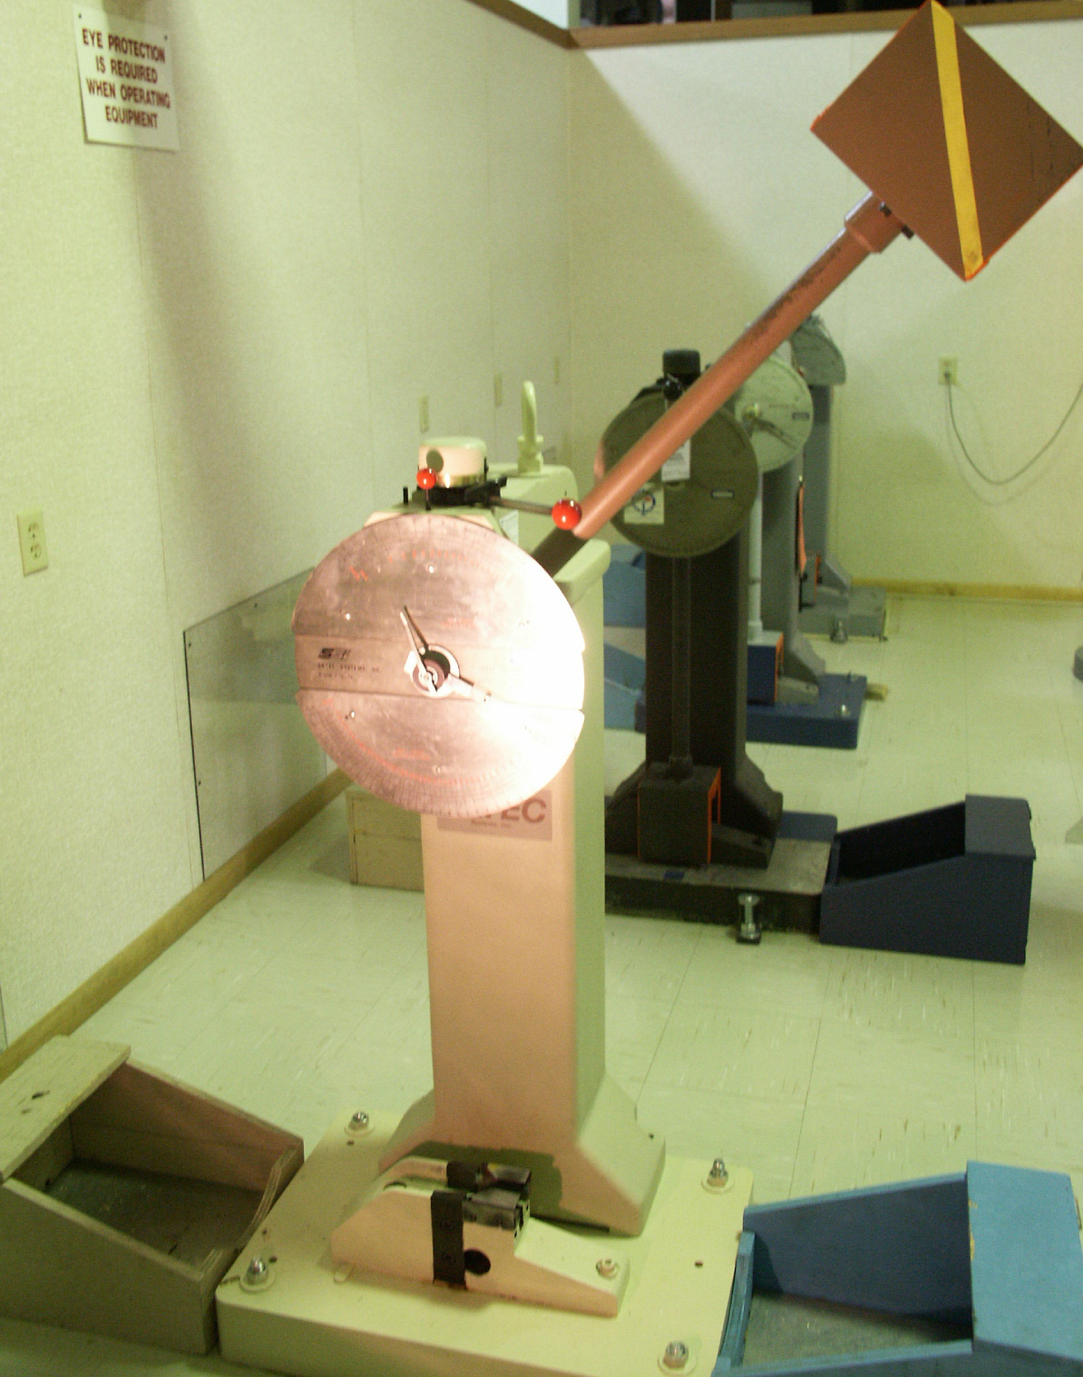

Image from: <http://www.wmtr.com/Content/charpy.htm>

**figure 3**

**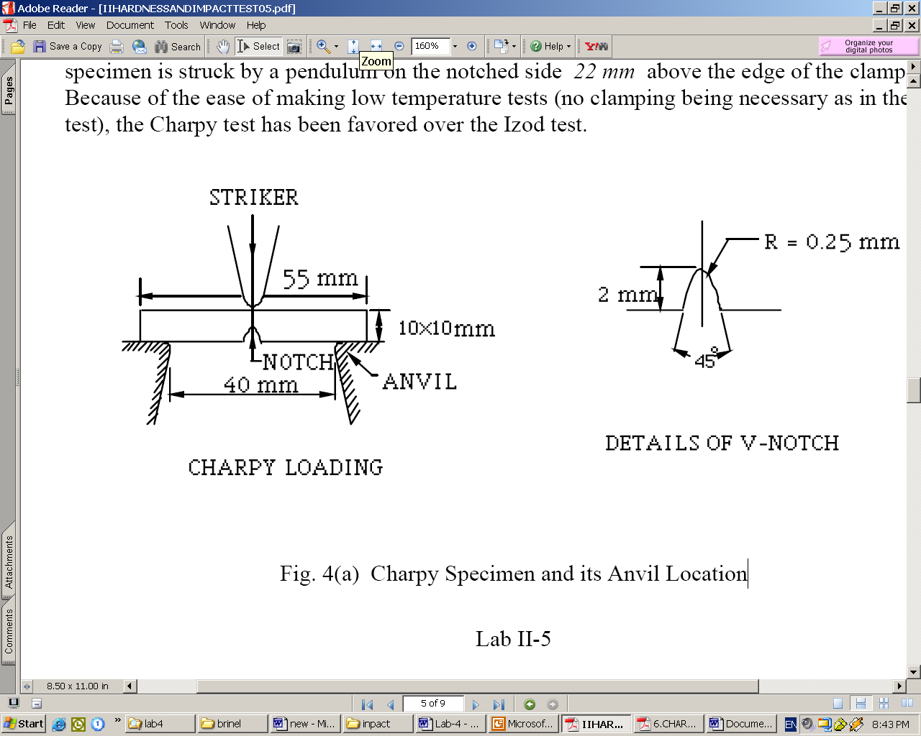**

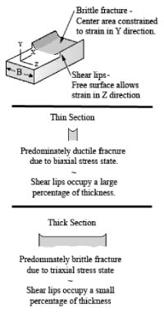

**Figure 4 Figure 5**

****

References:

* <http://en.wikipedia.org/wiki/Fracture_toughness#Table_of_values>
* Slides provided on Moodle.
* Textbook: Materials Science and Engineering: An Introduction, by W.D. Callister, 7th Ed., Wiley.
* <www.sciencedirect.com/science?_ob=ArticleURL>